DRAWINGS

FIG. 1 – System Architecture
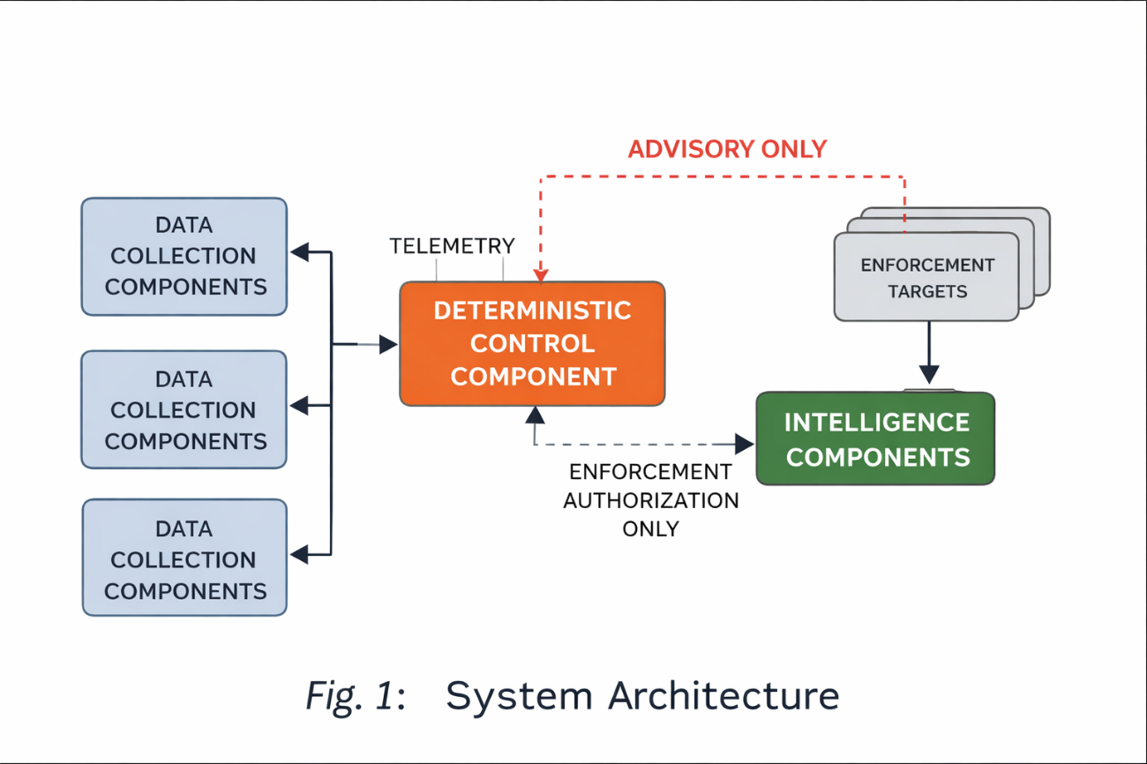
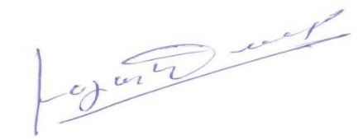
FIG. 2 – Enforcement Authorization Flow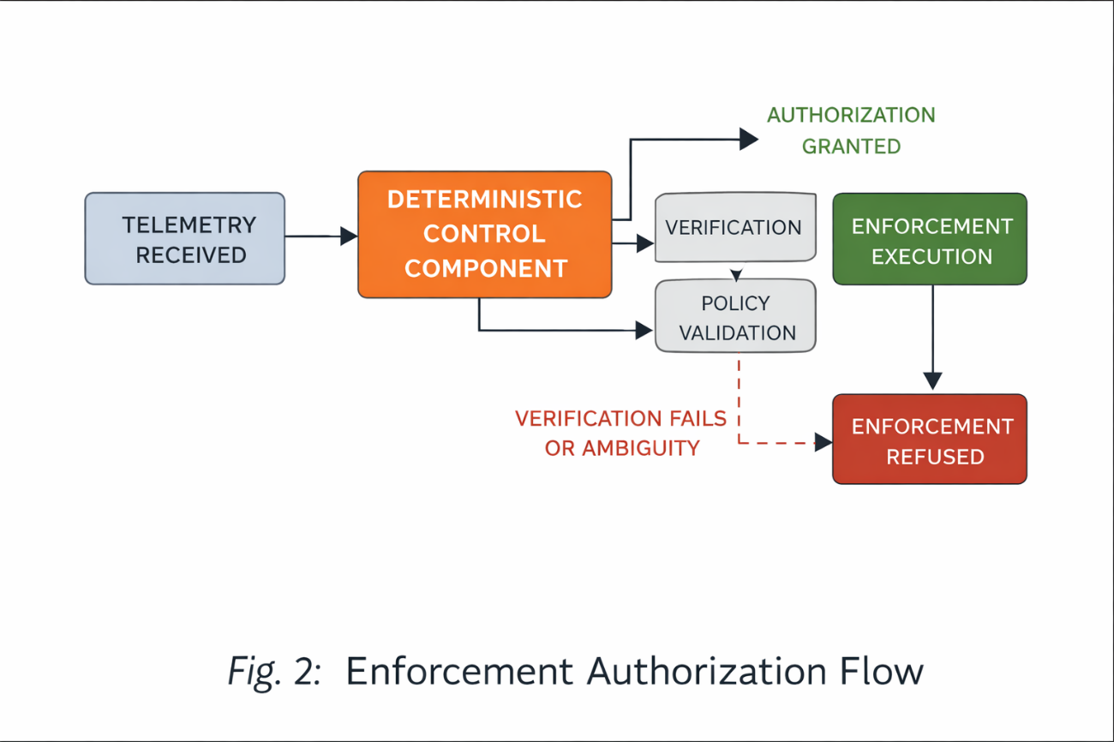
FIG. 3 – Intelligence Restriction
